Cluster Review Committee Recommendations for Public Comment

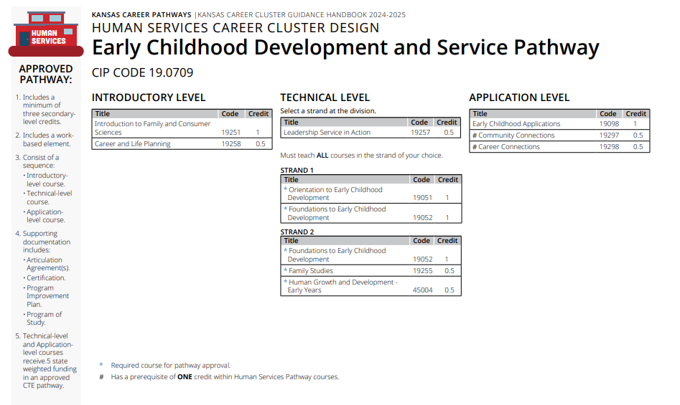
Section 1: Prior to the Cluster Review

Prior to Cluster Review

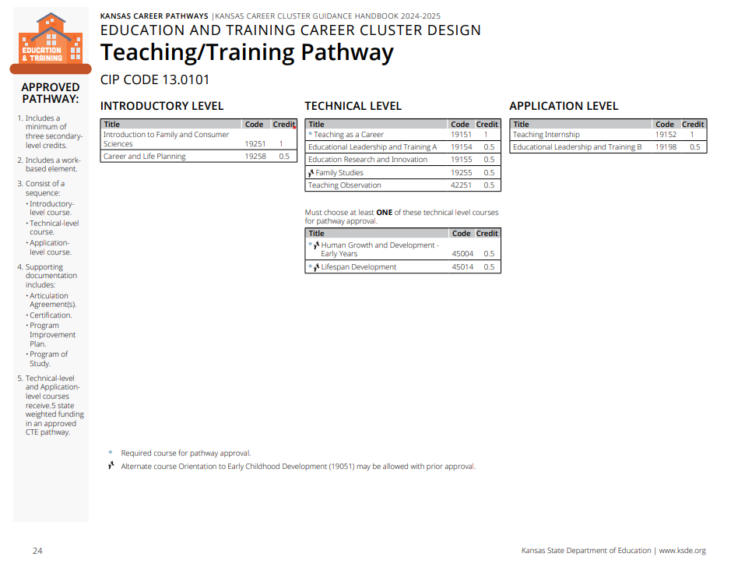
Prior to Cluster Review

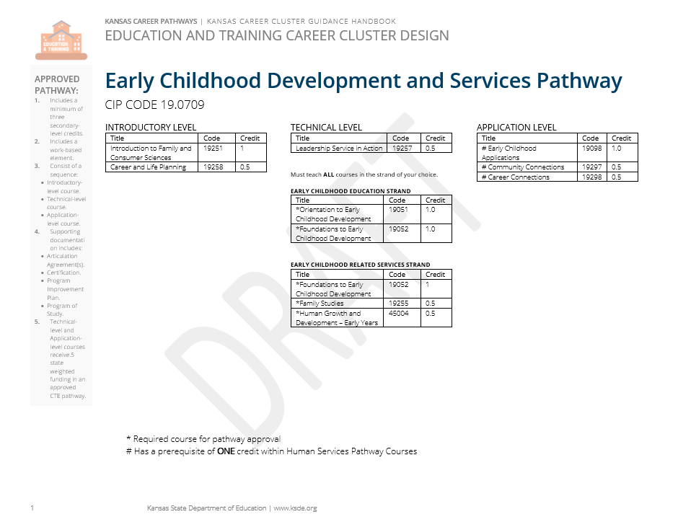
Section 2: Recommendations Following Cluster Review

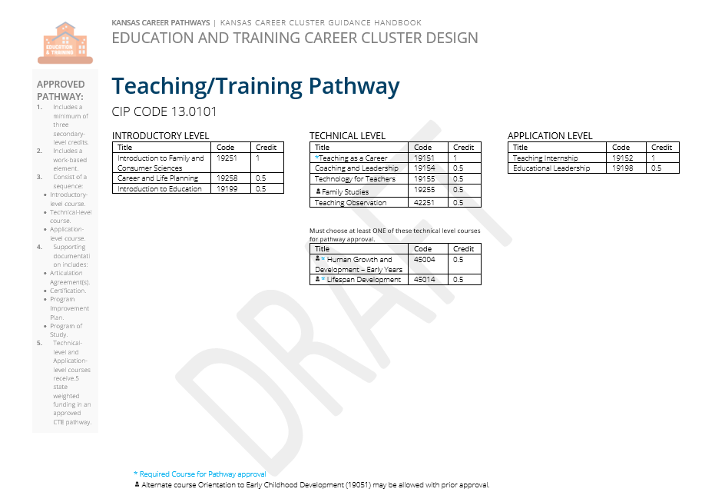

Section 3: Summary of Cluster Review Committee Recommended Changes

Cluster Level Changes
When reviewing the Education and Training Career Cluster - in addition to reviewing the pertinent labor, economic, and educational data, an emphasis was also placed on demonstrating the value of early childhood education to the larger education system. As a result of this research and discourse, the following recommendations were made to honor the critical partnership between early, elementary, and secondary education, while keeping these pathways in a common career field that most aligns with the necessary content and practical knowledge of a professional in those occupations.
- Move the Education and Training Cluster from the Public Services Career Field to the Family and Consumer Sciences Career Field on the Kansas CTE Sunflower Model.
- Move the Early Childhood Development and Services Pathway into the Education and Training Career Cluster within the Family and Consumer Sciences Career Field

NOTE: Due to the current work being done nationally through Advance CTE to modernize the Career Clusters Framework, some items are susceptible to change as the national framework is released (expected late 24-25), and work is done to compare the Kansas Career Cluster Framework to the National Career Cluster Framework.

Teach and Train Recommended Pathway Changes
In reviewing the course offerings of the Teach/Train Pathway (CIP 13.0101), an effort was made to broaden the accessibility of the pathway by adding an additional option for an introductory course. Additionally, competencies were edited, and course titles were amended for clarity to better illustrate the content of each course in the pathway.

- Add the new course “Introduction to Teaching (19199)” as an optional introductory level course.
- Change course title for “Educational Leadership and Training A (19154)” to “Coaching and Leadership (19154)”
- Change course title for “Education Research and Innovation (19155)” to “Technology for Teachers (19155)”
- Change course title for “Educational Leadership and Training B (19198)” to “Educational Leadership (19198)”

Early Childhood Development and Services Recommended Pathway Changes
Due to the recent review of the Human Services Career Cluster, courses in the Early Childhood Development and Services Pathways had already been reviewed at length. For the purposes of the Education and Training Cluster Review, the early childhood pathway courses were audited and used to further the discussion around the connection between early, elementary, and secondary education. Relevant secondary instructors, postsecondary leadership, and industry professionals were consulted in matters relating to the Early Childhood Pathway.

- Minor revisions to competencies in “Foundations to Early Childhood Development (19052)” and “Orientation to Early Childhood Development (19051)”
- Added names for “Strand 1” and “Strand 2” of the Pathway
  - “Strand 1” will become “Early Childhood Education Strand.”
  - “Strand 2” will become “Early Childhood Related Services Strand”

For more information, contact:  Taylor L. Spangler, CFCS  Educational Program Consultant – Family and Consumer Sciences  Career, Standards & Assessment Services  (785) 296-2307  tspangler@ksde.org |  | Kansas State Department of Education  900 S.W. Jackson Street, Suite 102  Topeka, Kansas 66612-1212  (785) 296-3201  www.ksde.org
The Kansas State Department of Education does not discriminate on the basis of race, color, national origin, sex, disability or age in its programs and activities and provides equal access to the Boy Scouts and other designated youth groups. The following person has been designated to handle inquiries regarding the nondiscrimination policies: KSDE General Counsel, Office of General Counsel, KSDE, Landon State Office Building, 900 S.W. Jackson, Suite 102, Topeka, KS 66612, (785) 296-3201.
February 2024

